### Phase 3 Testing

Previous testing demonstrated that vehicles were capable of exciting the mass of the structure. It became clear that we needed to better understand the coupled behavior of bridge and vehicle as it traversed the bridge. A test was therefore designed to capture the motion of a vehicle and bridge synchronously.

Sensors were installed on the bridge on June 26th and 27th of 2017. Testing occurred on June 28th. Sensors were removed on the 29th.

#### Instrumentation Plan

Accelerometers were distributed along the length of the bridge as well as placed on a test vehicle. This necessitated distributed data acquisition systems, one of which had to operate in a moving vehicle. GPS acquired time was used to provide synchronization.

Three National Instruments CompactRIO (cRIO) controllers outfitted with NI9234 modules for acquisition of the dynamic data were used. One was placed on the test truck; another was placed beneath span 3 and another beneath span 7. A total of 36 accelerometers (PCB Model 393A03) were installed on the bridge, distributed on spans 2, 3, 4, 7, and 8. They were positioned, as shown in the following figures, in regions that experience the greatest deformation for the first several modes of vibration.

Another 4 accelerometers were attached to the corners of a dump truck bed so the “roll”, “pitch” and “bounce” of the main mass of the vehicle could be captured. Video cameras were placed at the beginning and end of the bridge, as well as at an elevated position near span 2.

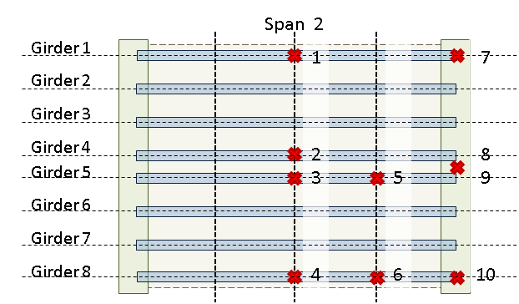

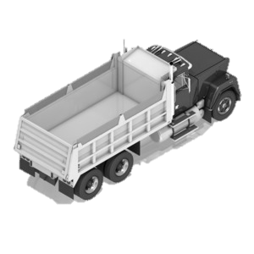

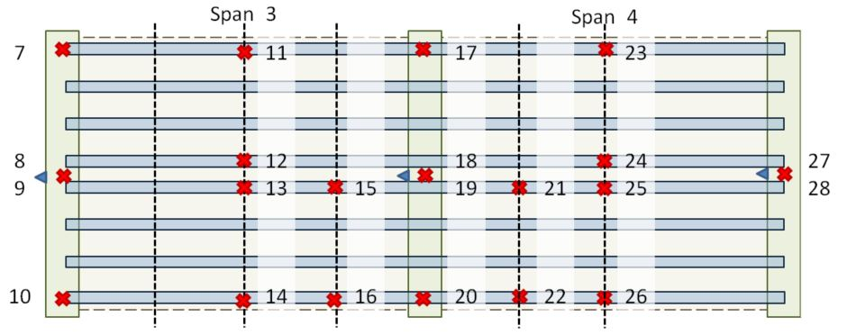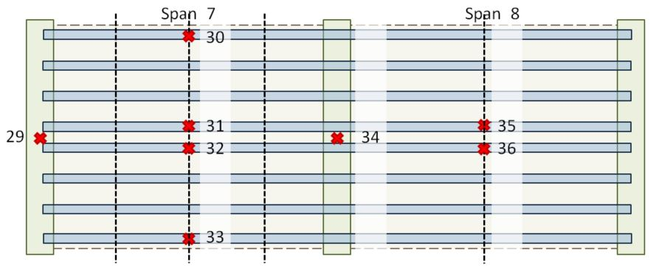

#### Test Activities

The dump truck was loaded to a total weight 47940 lbs. (21745 kg) at the DOT truckyard. Truck weight was measured by measuring individual wheel weights with a wheel/axle scale (Intercomp LP600). While it was intended that gauges be placed at the four corners of the truck body, this particular truck body was aluminum and therefore the mounting magnets were ineffectual. The rear two magnets were able to be placed where intended thanks to steel hardware. The front two sensors were attached to the vehicle chassis in-line with the front edge of the bucket. Cables were clamped to the vehicle body and the DAQ was placed under the passenger’s feet who operated the DAQ and recorded meta data.

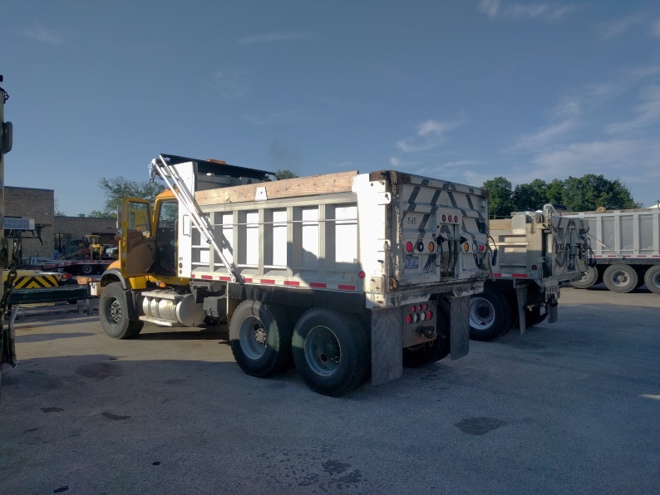

The test truck traversed the bridge 14 times. Vehicle speed and lane position were varied between runs but kept consistent throughout a single pass. Traffic conditions varied from free-flowing to heavily congested. All 3 DAQs recorded data at 1652 Hz. Crossing events were marked in the data files by a passenger in the test truck by tapping a designated accelerometer just before entering the bridge and just after exiting it. The following table summarizes the meta data for each run.

|  |  |  |  |  |
| --- | --- | --- | --- | --- |
| Run # | Lane | Direction of Travel | Average Speed (mph) | Traffic Conditions |
| 1 | L | WB | 60 – 30 | Stopped near end of bridge |
| 2 | R | EB | 35 | Light |
| 3 | R | WB | 42 | Moderate |
| 4 | R | EB | 25 | Moderate |
| 5 | L | WB | 40 – 0 | Heavy with stop at end |
| 6 | L | EB | 40 | Light |
| 7 | L | WB | 15 | Heavy |
| 8 | L | EB | 47 | Light |
| 9 | L | WB | 58 | Light |
| 10 | R | EB | 20 | Light |
| 11 | R | WB | 10 | Moderate to light |
| 12 | L | EB | 40 | Light |
| 13 | R | WB | 35 | Light |
| 14 | R | EB | 40 | Light |

Accelerometers were removed from the test truck at the conclusion of testing. All sensors were removed from the structure the day after testing.

#### Results & Interpretation

Acceleration records for the bridge show that it was excited by the test truck. As can be seen in Figure X, the structure experiences large vibrations shortly after the test truck enters the span. Data for some channels have been clipped for plot clarity.

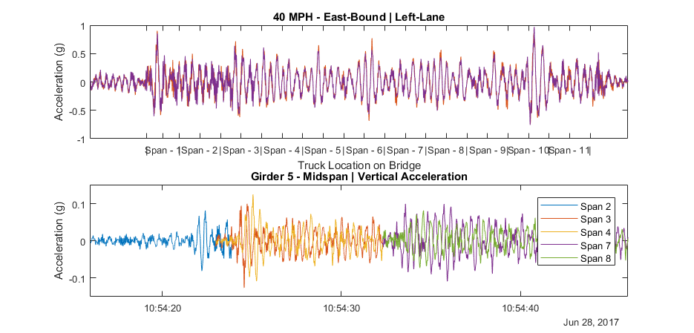

Figure X …

Examination of acceleration records for the test truck reveal that its motion is greatly increased when it is on the bridge deck versus when it is on normal roadway and acceleration increases with increased vehicle speed. The plot below uses the short-time Fourier transform (STFT) to show the frequency content of the truck acceleration as it changes over time. It is evident from the plot that the truck begins to resonate shortly after entering the bridge at a frequency of 2-3Hz.

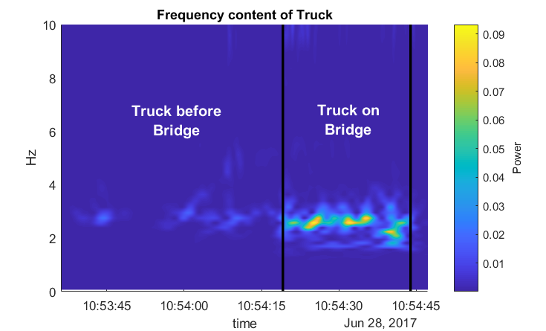

Spectral analysis of truck acceleration data on normal roadway shows the truck has a natural frequency of approximately 2.7Hz. High damping in the vehicle serves to broaden the natural frequency peak, preventing precise modal parameter identification but also providing a range of forcing frequency content that could induce resonance in the truck.



These test results further confirm that the bridge vibrations are a result of vehicle-bridge interaction in which both the vehicle and bridge are experiencing significant excitation. Simulation is required for further understanding of the mechanisms and influential parameters associated with this behavior.

#### FE Simulation

An FE software package was chosen (LUSAS) that was capable of simulating vehicle-bridge interaction. This required the ability to model the geometry and dynamics of the bridge as well as the dynamics of a vehicle traveling over the bridge model. A plate and eccentric-beam (PEB) modelling approach was employed to reduce model complexity in anticipation of computationally heavy simulations. The geometry and material properties were assigned to match those of the 3D FE model that had already been validated. The two-span model detailed below was replicated to produce a model of all 11 spans of the bridge.

##### Model Form - Plate Eccentric-Beam Modeling

This class of model is much like a grillage model in that the vertical dimension of the bridge is flattened resulting in a 2D model. However, for a PEB model, the girders are offset from the deck plane. For the models used in this study, the offset was specified in the element attributes rather than physically relocating the beam nodes. In this way strain compatibility (and thus composite-action) was implicitly enforced between the deck and girders as their nodes were coincident. The cross-girders, in contrast, were modeled at the elevation of their centroidal axis thereby allowing for correct placement of boundary conditions and making it easier for a given box-girder to support adjacent discontinuous spans.

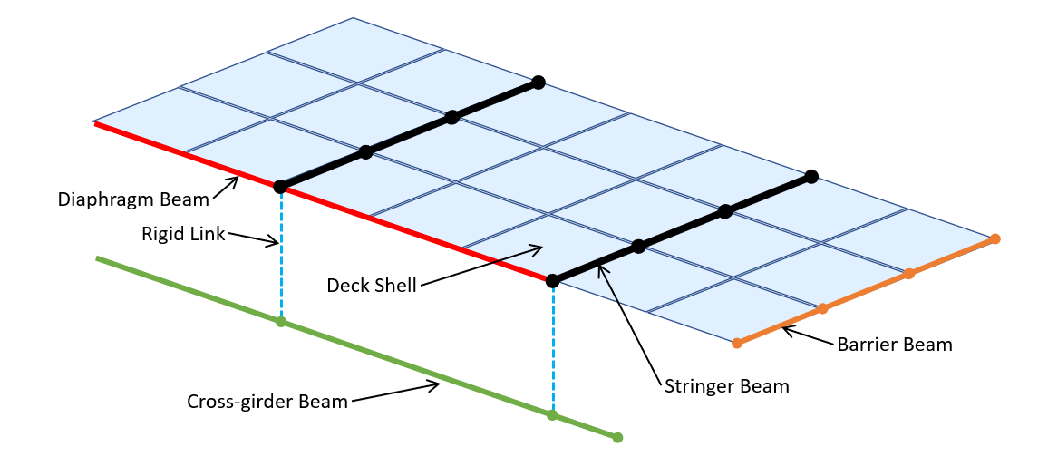

Due to the 2D nature of the model type, the chevron and x-framed diaphragms were represented with 2D beam elements coplanar with the deck. Care was taken to ensure the nodes of these diaphragm beam elements did not coincide with deck nodes except at girder intersections so as to prevent composite action between diaphragms and deck. The diaphragm beam elements were assigned a stiffness such that the structural natural frequencies matched those of the previously validated model and experimental data.

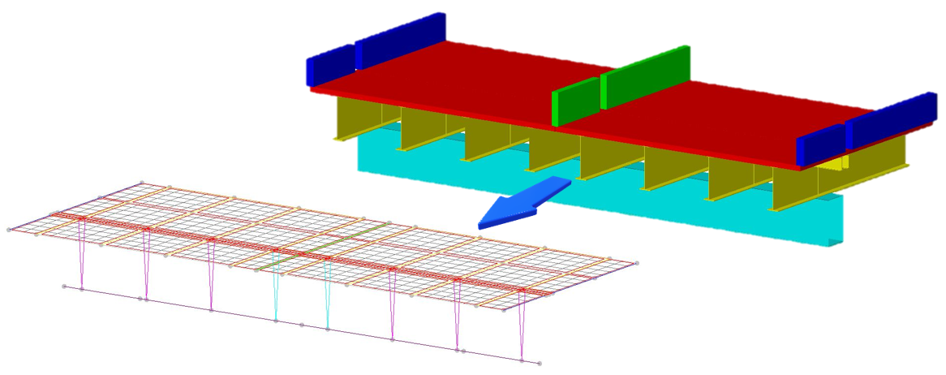

The elevation of those elements which act compositely with the deck is important for accuracy, and while they were modeled on a single plane, the eccentricity of the elements was specified to effectively offset the elements to the correct elevation while maintaining the simplicity of the model. The image above shows the effective elevation of components when rendered with specified eccentricities.

##### Bearings and Pedestals

Beam elements with very high stiffness and zero density (weightless) were used in place of rigid links to connect the cross-girder beam nodes to the stringer nodes since LUSAS does not include rigid links in their element library. These beam elements had all rotation released at the top end. The following table summarizes the additional translational releases assigned. Girders 4 & 5 were also restrained transversely with what is commonly referred to as an alignment bearing.

|  |  |  |  |  |
| --- | --- | --- | --- | --- |
|  | TX | TY | TZ |  |
| Fixed (Pedestals) | F | F | F |
| Expansion (Elastomeric) | R | F | R |
| Expansion (Alignment) | F | F | R |
| F – fixed; R – released | | | |

The cross-girders were assigned boundary conditions by applying restraint to two nodes. Translation was restrained in all three principle directions as well as rotation about the girder’s length. The rotational restraint was necessary to maintain stability and accurately represent the bolted connection between pier and box-girder. The following table summarizes the restraint applied to the nodes at either end of the cross-girder.

|  |  |  |  |  |  |  |  |
| --- | --- | --- | --- | --- | --- | --- | --- |
|  | DX | DY | DZ | RX | RY | RZ |  |
| @ East Piers | F | F | F | F | R | R |
| @ West Piers | R | F | F | F | R | R |
| F – fixed; R – released | | | | | | |

##### Model Updating/Validation

An initial comparison of experimental and model predicted mode shapes revealed that the predicted first bending mode had larger deflections along the exterior of the bridge compared to the experimental results.

|  |  |
| --- | --- |
| FE Predicted 1st Mode | Experimental 1st Mode |

The discrepancy suggested that the exterior regions of the bridge had less mass/greater stiffness, or the center region had greater mass/decreased stiffness. The barriers are the major components that differ for these two regions, therefore these were the first to receive further scrutiny.

Upon re-examination of construction documents and pictures of the bridge it became clear that the center barriers had saw cuts at approximately every twelve feet. These cuts were represented by releasing rotations and longitudinal translation at beam ends (approximately every 12 feet). Alternatively, the stiffness of the barriers could be set nominally low; however, this method tends to create unreal local modes of vibration. The exterior barriers were released over the central supports, as they appeared to be discontinuous at this point in pictures. These releases consisted of all three principle rotations, along with translation in the transverse and longitudinal directions (global).

After making the described adjustments to the barriers in the model, the natural modes and frequencies were recalculated and compared with experimental results. While the shape and frequency of the first mode was now in good agreement, the predicted frequency of a higher mode was nearly 0.4 Hertz lower than that determined experimentally, while the rest of the predicted mode shapes were in good agreement with experimental results.

|  |  |
| --- | --- |
| FE Predicted 3rd Mode – 2.45 Hz | Experimental 5th Mode – 2.8 Hz |

To improvethe prediction of the 3rd mode frequency, those components that experienced significant curvature in this mode were examined first, especially those that experienced relatively little curvature in other modes. The moment of inertia of the I-girders in the negative moment region was checked and found to be consistent with the drawings as well as to have little impact on the frequency of the mode.

The central box girder displayed significant deformation for this mode and was the next component to be investigated. The mode was found to be sensitive to its stiffness by studying the effects of altering its moment of inertia. However, as there was a high degree of confidence in the girder’s section properties, the boundary conditions of the box girder were ultimately chosen for modification. The box-girder supports were already represented with fixed translational degrees of freedom as well as rotation about the transverse axis. Rotation about the longitudinal axis was restrained by specifying a spring stiffness of 5x1010 lb-in/rad. This value was determined through incremental adjustment until the predicted and experimental frequencies sufficiently matched.

With the aforementioned adjustments completed, the natural frequency results of the FE model were in good agreement with the experimental results as can be seen in the summary table below.

|  |  |  |  |  |
| --- | --- | --- | --- | --- |
|  | Experiment | LUSAS FEM | % Error | |
| Mode 1 | 2.0 | 2.03 | 1.5% | |
| Mode 2 | 2.1 | 2.07 | 1.4% | |
| Mode 3 | 2.44 | 2.49 | 2.0% | |
| Mode 4 | 2.54 | 2.50 | 1.6% | |
| Mode 5 | 2.83 | 2.82 | 0.4% | |
| Mode 6 | 3.2 | 3.14 | 1.9% | |
| Mode 7 | 3.56 | 3.63 | 2.0% | |
| Mode 8 | 3.56 | 3.63 | 2.0% |

##### Full Model

Once the two-span model was updated to be in better agreement with the measured responses, , a more comprehensive model was constructed that included all eleven spans of the viaduct. Deck elements were left separated by ½ in. where discontinuous spans met. Furthermore, by utilizing adjacent, independent “pedestal” elements, the box-girder element supported the two different spans without forcing continuity between their components (deck and girders).

**Connectivity at discontinuous joints**

##### Vehicle Modeling

The vehicle model was developed from the experimental data. The mass of the truck was measured by statically weighing the truck on scales. The acceleration data of the truck was processed using PSD methods and the frequency of the first mode of vibration was determined. Using the relationship for the frequency of a single degree-of-freedom system, the stiffness of the suspension can be determined according to the following equation.

|  |  |
| --- | --- |
|  | (1) |

Analysis of truck acceleration records show a first mode of vibration at 2.8 Hz. Assuming, 45 kips of the truck weight are carried by the suspension, the suspension stiffness is computed to be 36 kip/in. The damping coefficient (cs) was assigned to achieve 10% of critical damping. The coefficient value was therefore calculated by the following equation.

|  |  |
| --- | --- |
|  | (2) |

While the test truck is more complex than a single degree-of-freedom system, effort was first made to see if this simplification could still yield satisfactory results (i.e. responses similar to what was measured in the field).

The initial vehicle model parameter values are summarized in the following table.

|  |  |  |  |  |  |  |  |  |  |  |  |  |  |  |  |  |
| --- | --- | --- | --- | --- | --- | --- | --- | --- | --- | --- | --- | --- | --- | --- | --- | --- |
| |  |  |  | | --- | --- | --- | |  | Value | Units | | ks | 36000 | lb/in | | cs | 410 (10%) | lb-s/in | | ms | 116.55 | lb-s2/in | | mu | 0 | lb-s2/in | |  |

##### Profile Consideration

Initial simulations did not include any roadway profile and therefore inherently assumed a perfectly smooth profile. It very soon became clear that neglecting the roadway profile in the simulations greatly under-predicts the bridge responses. The in-situ roadway profile was subsequently measured for implementation in further simulations.

The profile was recorded using an Ames Engineering Model 8300 Portable Profiler. Two passes were made on each lane. Both wheel lines of the profile were sampled at 1-inch intervals.

Profiles were converted to csv files, each of which contained an array of distances and an array of corresponding elevations for right and left wheel lines using the ProVAL software. MATLAB was then used to convert the data in the csv file so that it could be directly imported into the LUSAS software for simulation. A custom MATLAB script made the following changes to the data:

* Profile is trimmed to a specified distance before the beginning of the bridge
* Distance values are converted to inches and made to start from 0 at the beginning of the profile
* The profile elevation values, over a specified distance from the profile start, are replaced with linearly increasing/decreasing values so as to provide a “ramp” up to the profile
* New distance and elevation arrays are saved to a text file.

The ramp in the profile data prevents the large initial energy input that would result from a sudden step in the profile. A ramp of 20 feet was specified. The profile was trimmed such that it began 500 feet before the beginning of the bridge, allowing ample time for the vehicle to develop its initial conditions. A sample of the profile for an east-bound right lane is shown below.

Simulations were performed with the measured profiles. The vertical acceleration at mid-span of span 3 from simulation with this profile is plotted below and compared with the results from simulation with no profile. These results provide clear indication that the profile has a great influence on vehicle-bridge interaction.

Figure 7: Comparison of span 3 midspan acceleration for simulations with and without a profile included

Figure 8: Comparison of truck vertical acceleration for simulations with and without a profile included

##### Validation of VBI Simulation Methods

In an effort to make simulation results match the experiment, the mass, stiffness and damping of the vehicle model was the adjusted until a good fit was acquired. Damping ratios of 5, 7, 10 and 20 percent were investigated. Mass and stiffness were increased (while maintaining 2.9 Hz frequency) but they were ultimately bounded by the field measurements, and therefore, were relatively certain parameters. Suspension stiffness had minimal effect on truck acceleration, while decreased damping significantly increased truck acceleration. A truck model with the parameters listed in Table X ultimately resulted truck acceleration that best matched the experimental data.

|  |  |  |  |  |  |  |  |  |  |  |  |  |  |  |  |  |
| --- | --- | --- | --- | --- | --- | --- | --- | --- | --- | --- | --- | --- | --- | --- | --- | --- |
| |  |  |  | | --- | --- | --- | |  | Value | Units | | ks | 36000 | lb/in | | cs | 429 (10%) | lb-s/in | | ms | 116.55 | lb-s2/in | | mu | 0.0052 | lb-s2/in | |  |

The following plot compares experimental acceleration data to FE simulation with this vehicle model. Simulations were performed with the path of travel located in center of the right-hand lane of the east-bound side and the measured profile of the right wheel line.

Figure 9: Truck vertical acceleration (simulation vs. experimental)

Figure 10: Bridge vertical acceleration at midspan of span 3

Figure 11: Bridge vertical acceleration at midspan of span 7

These simulation results demonstrate the model’s capability of simulating vehicle-bridge interaction and the role of roadway profile on that interaction.

### Test Conclusions

As a result of the tests performed on the case structure the following may be concluded.

* The bridge is experiencing motion that exceeds human comfort criterion.
* The high vibration levels are occurring on all spans (that were instrumented).
* The bridge exhibits dynamic amplification as high as 1.75 even under heavy vehicles (compared to AASHTO recommended 1.33).
* The high dynamic amplification is not a result of any structural deficiency or anomaly.
* The high dynamic amplification does not seem to pose a risk to the structure’s performance (at strength or service limit states).
* The vehicle is excited by the bridge deck profile, which in-turn excited the bridge
* A validated 3D FE model is capable of simulating bridge-vehicle interaction if roadway profile is included and accurately positioned on the model.

The framework of structural identification was followed throughout the many tests performed on this test structure. In this way testing provided ground truth of behavior which served to validate simulation tools, which were, in-turn, leveraged to investigate structural behavior that would be impossible or impractical to capture in the field. The remainder of this paper implements these validated tools to gain further understanding of vehicle-bridge interaction and dynamic amplification.

## Simplified VBI Model

In several of the simulation studies described in this section a simplified model was employed. This model is composed of 2 degrees-of-freedom and reduces the bridge to a single beam. This model type was used when appropriate due to the minimal computing power required, permitting a large number of simulations to be automated and performed in a relatively short amount of time. This model (state-space) is described in detail in the second part of this document and in the appendix.

### Bridge and vehicle decoupled

In the interest of further understanding the degree to which the vehicle and bridge interact, the vehicle is analyzed separately from the bridge. The vehicle is first analyzed traveling over just the profile. The contact force obtained as a result of this analysis is then applied to the bridge model. This method neglects bridge motion and therefore represents a completely rigid bridge. Therefore, this method’s accuracy will suffer with increased bridge flexibility and vehicle mass.

|  |  |  |
| --- | --- | --- |
|  |  |  |

Figure 12: Diagram of Decoupled Model

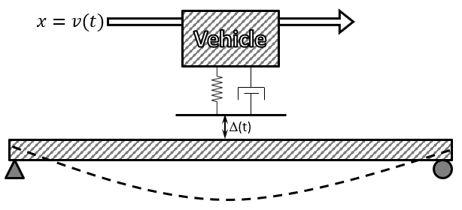

Figure 13: Diagram of Coupled 2-DOF Model

None of the readily available FEM software packages had the capability to apply both time and spatially varying loads, therefore the simplified 2-DOF was used for this demonstration. The following plot compares the bridge response from this uncoupled analysis to that from the coupled vehicle-bridge model.



Despite the simplicity of the model used to obtain the above results, it is still effective at modelling the exchange of energy of two systems. As can be seen, decoupling the bridge and vehicle in simulations reduces the accuracy of the analysis and tends to overestimate the bridge response, especially at higher levels of amplification. It is therefore recommended that any simulation of bridges under vehicle crossings include the interaction of the two systems.

### Mechanisms and Influential Attributes

Many studies on vehicle-bridge interaction will examine the role of parameters separately, and it was the original intention to organize this study in a similar manner. However, as it will soon be made clear, the parameters that effect VBI are interdependent. The following section therefore seeks to demonstrate and characterize the interdependency by first examining roadway profile which the case study showed to be critical to VBI and dynamic amplification.

A given profile is composed of elevation changes over the length of the roadway. This surface may be approximated by a summation of harmonic functions, and thus spectral analysis may be performed in much the same way as was done for acceleration data. The profile can therefore be described by its spatial frequency (cycles per unit distance) content. When a vehicle travels over a harmonic profile, the elevation change experienced at the vehicle’s location is harmonic according to the velocity of the vehicle. A profile with a given spatial frequency will induce a force that acts on the vehicle with a frequency equal to the product of the spatial frequency and vehicle velocity. Therefore, the effect of the profile spatial frequency content is dependent on the velocity of the vehicle.

Several simulations with a 3D FE model (140ft; single-span) were performed for a sinusoidal profile with 30-foot wavelength and ½ in. amplitude. The bridge model had the first and second natural frequencies between 2.2 and 2.5 Hz, while the first natural frequency of the vehicle model was 2.8 Hz. The plot below shows the peak vehicle and bridge response at different vehicle speeds and the resulting forcing frequencies. It is no surprise that the peak responses occur at speeds that induce a forcing frequency that matches their respective natural frequency.

The bridge displacement amplification is calculated by dividing the maximum midspan displacement by the static bridge displacement. The vehicle contact force amplification is calculated by dividing the maximum contact force by the vehicle’s weight.

#### Multi-dimensional parametric study

Additional simulation was performed with the simplified state-space model. Vehicle stiffness was varied to produce vehicle models with natural frequencies ranging from 2 to 5 Hz. Bridge stiffness was also varied to produce bridge models with natural frequencies of the same range. Simulations were performed with the same harmonic profile with a wavelength of 30 ft. Vehicle speeds ranged from 540 to 2400 in/sec (10-136 mph) to produce forcing frequencies between 1.5 and 6.7 Hz.

|  |  |  |  |  |  |
| --- | --- | --- | --- | --- | --- |
|  | Bridge 1 | Bridge 2 | Bridge 3 | Bridge 4 |  |
| Span Length | 100 | 100 | 100 | 100 | ft |
| Mass (total) | 2000 | 2000 | 2000 | 2000 | slinch |
| EI | 5.603E+12 | 1.261E+13 | 2.241E+13 | 3.502E+13 | lb-in2 |
| Damping Ratio | 1.0% | 1.0% | 1.0% | 1.0% |  |
| 1st Nat. Freq. | 2 | 3 | 4 | 5 | Hz |

|  |  |  |  |  |  |
| --- | --- | --- | --- | --- | --- |
|  | Truck 1 | Truck 2 | Truck 3 | Truck 4 |  |
| Mass | 200 | 200 | 200 | 200 | slinch |
| spring k | 31582.7 | 71061.2 | 126330.9 | 197392.1 | lb/in |
| Damping Ratio | 10.0% | 10.0% | 10.0% | 10.0% |  |
| Nat. Freq. | 2 | 3 | 4 | 5 | Hz |

The following plot summarizes the results of this parametric study.

|  |  |  |  |
| --- | --- | --- | --- |
| Bridge Displacement Amplification |  | | Vehicle Contact Force Amplification |
|  | Forcing Frequency (Hz) | Bridge Response  Vehicle Response | |

In the preceding figure the amplification of bridge and vehicle responses is plotted. The bridge displacement amplification is calculated by dividing the maximum midspan displacement by the static response given by the following:

|  |  |
| --- | --- |
|  | (3) |

The vehicle contact force amplification is calculated by dividing the maximum contact force by the static force of the vehicle which is merely the vehicle’s weight.

The above plot demonstrates the role of the profile as well as other parameters in vehicle-bridge interaction. The profile best excites the vehicle when its forcing frequency matches that of the vehicle, and the bridge is most excited when the profile forcing frequency matches its own natural frequency and that of the vehicle.

However even a harmonic profile cannot be entirely described by its frequency content alone. The distribution of phase angles for the different harmonic components have a large effect on the final form of the profile and how the vehicle-bridge system responds to that profile. The following plot compares bridge response for two profiles with identical frequency content but different phase angle distribution. Simulations were performed with a 3D FE model of a bridge with 140 ft. span length and profiles created according to ISO 8608 standards (C10 = 300; w = -2).

Figure 14: Bridge displacement for profiles with different phase distribution

As can be seen, two profiles with identical frequency content but different phase angle distribution will cause different bridge responses. Similarly, the position of the profile can make a large difference in vehicle and bridge response. Simulations were performed with one of the profiles used in the previous simulation using the 2-DOF simplified model (Bridge 1 & Truck 1). The position of the profile was varied by offsetting it in increments of 5 feet.



As can be seen in the plot above, the bridge response varies greatly by just adjusting the position of the profile on the bridge. Furthermore, most real profiles are not harmonic but rather have many transient features. Profiles that contain features with large wavelengths that result in forcing frequencies similar to vehicles or the bridge should be avoided (e.g 5-50ft.). However, the frequency content of the profile alone has no reliable correlation with dynamic amplification and spatial information must be included in any dynamic amplification analysis.

Vehicle and bridge parameters therefore effect dynamic amplification based on their influence on the dynamics of the system and how those system dynamics relate to the profile characteristics. While parameter effect cannot be quantified they can still be generalized as follows:

* Higher bridge mass, stiffness and damping generally serve to reduce dynamic amplification.
* Higher vehicle mass increases dynamic amplification while vehicle damping helps to reduce amplification.
* Higher vehicle speed leads to increased dynamic amplification.
* Longer bridge length results in a longer period of time for which the vehicle is present on the bridge and may therefore result in greater dynamic amplification.

Anything further than these generalizations requires simulation of vehicle-bridge interaction with the specific profile or direct measurement by field experiment.